* ***University****:* JNU
* ***Department****:* Computer Science and Technology
* ***Course****:*Human-Computer Interaction
* ***Project Title****:* GitHub Project (Facial detection and emotion recognition)
* ***Project Part****:* Part 4
* ***Author****:*蒋云翔 2022102330（Yunxiang Jiang）（Accomplish the task by myself only）
* ***Instructor****:*龙锦益（Jinyi Long）
* ***Date****:* December 4, 2024

Catalogue

1. Brief Introduction to GitHub project 2

1.1 Website URL: 2

1.2 Project’s brief introduction 2

2. Develop environment 5

3. Running result analysis 7

# 1. Brief Introduction to GitHub project

## 1.1 Website URL:

[serengil/deepface: A Lightweight Face Recognition and Facial Attribute Analysis (Age, Gender, Emotion and Race) Library for Python](https://github.com/serengil/deepface?tab=readme-ov-file)

Figure 1: GitHub URL link

## 1.2 Project’s brief introduction

***DeepFace*** is a lightweight face recognition and facial attribute analysis (age, gender, emotion and race) framework for python. It is a hybrid face recognition framework wrapping state-of-the-art models: ***VGG-Face, FaceNet, OpenFace, DeepFace, DeepID, ArcFace, Dlib, SFace and GhostFaceNet***.

Experiments show that human beings have ***97.53%*** accuracy on facial recognition tasks whereas those models already reached and passed that accuracy level.

Figure 2: The README file of the project

图表

Figure 3: The related models that be used in deepFace

***FaceNet, VGG-Face, ArcFace and Dlib*** are overperforming ones based on experiments - see **BENCHMARKS** for more details. You can find the **measured** **scores** of various models in DeepFace and the **reported scores** from their original studies in the following table.

Figure 4: The measured and Declared score of different models

This can be used to detect and recognize a variety of information, such as age, gender, emotion, race, etc. Our project mainly applies its function of **identifying emotions**.

Figure 5: A using example of deepFace

# 2. Develop environment

This is an integrated package, which contains the we need such as TensorFlow, matplotlib, OpenCV python, NumPy, pandas and so on.

Figure 6: The instruction of environment building method

Figure 7: Configure our project environment

There were some ***minor incidents*** during the configuration experiment. Since this project was created several years ago, the configuration environment at that time was ***a little older than the current one***, so I needed to configure some packages with older versions to meet this project. So I used ***anaconda*** to create a python 3.9 virtual environment to run the project

Figure 8: Using anaconda to create virtual env

# 3. Running result analysis

In the analyze module of deepFace, emotions can be recognized as follows: ***angry, disgust, fear, happy, sad, surprise and neutral***. This model will weigh and score the recognized emotions in the image, and finally get a ***dominant_emotion*** as the final judgment result

Figure 9: Test example (Happy emotion recognition)

Figure 10: Test example (Angry emotion recognition)

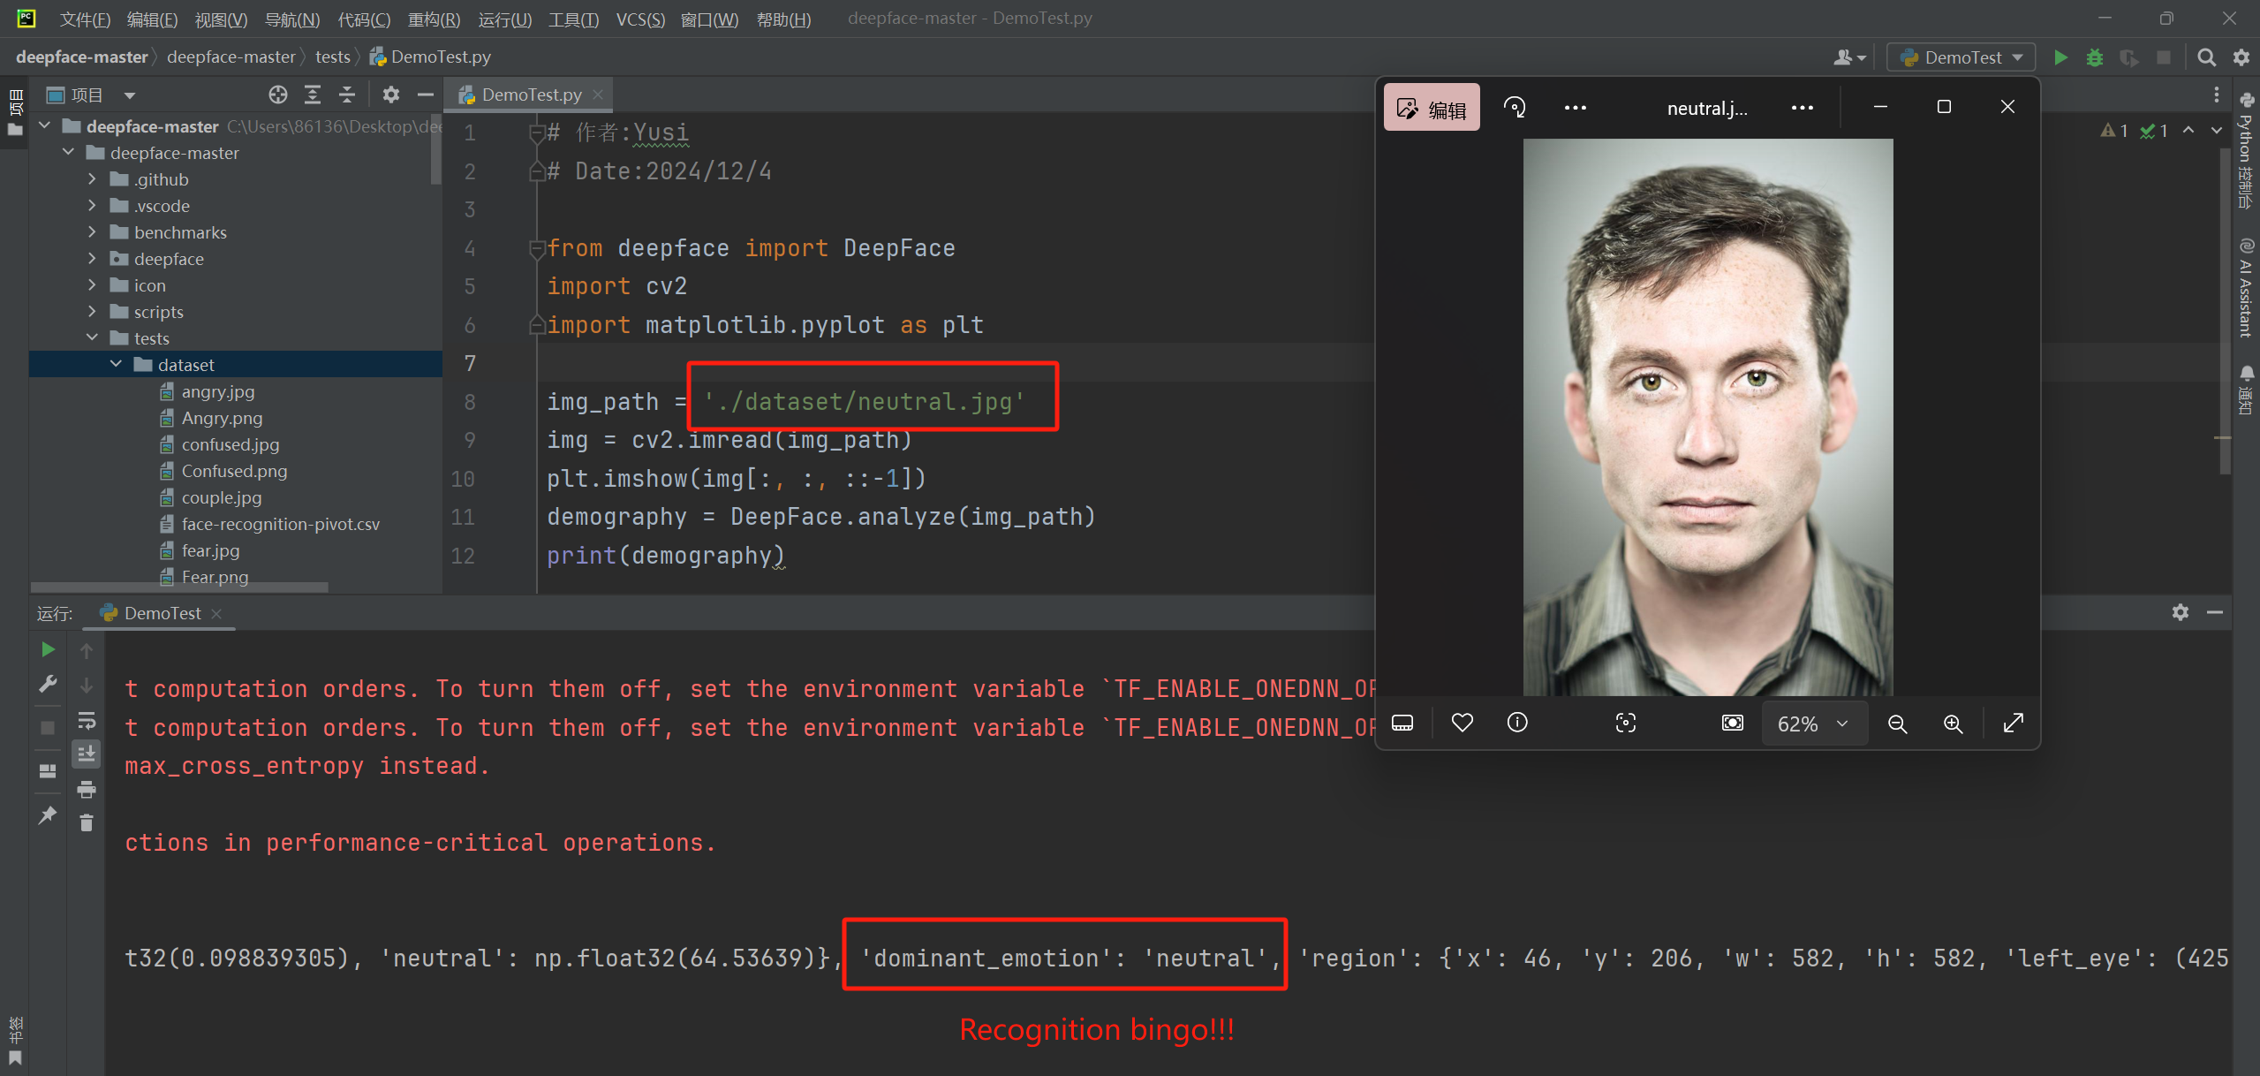

Figure 11: Test example (Neutral emotion recognition)

Figure 12: Test example (Sad emotion recognition)

Figure 13: Test example (Fear emotion recognition)

As you can see, all our test cases produced correct mood predictions!!